Where To Get Your FREE Genesis Character Bundles

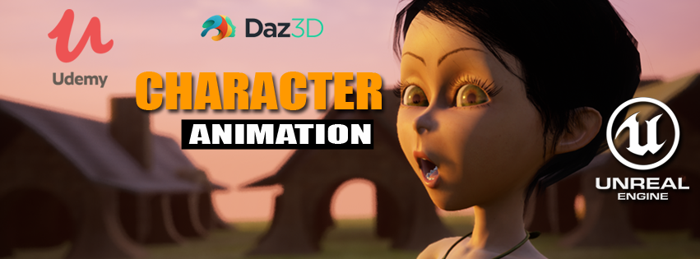

**You can get all the Genesis base characters for free at the DAZ store:**

**Genesis Starter Essentials**

<https://www.daz3d.com/genesis-starter-essentials>

**Genesis 2 Starter Essentials**

<https://www.daz3d.com/genesis-2-female>

**Genesis 3 Starter Essentials**  
<https://www.daz3d.com/genesis-3-starter-essentials>

**Genesis 8 Starter Essentials**  
<https://www.daz3d.com/genesis-8-starter-essentials>

There is a lot of really good stuff in these bundles!

Enjoy & Happy Animating!